MENU

TOPIC PAGE

1. Introduction
2. ER Diagram
3. Normalization
4. DDL & DML
5. Constraint
6. Sequence
7. Query Question
8. Relational Algebra

Introduction

Travel agency is identified by t_id, and its name, age, address, contact, email, salary must be recorded. And a travel agency has at least one client. Travel agency has many contact and email.

Clients are identified by c_id. For each client, the name, age, address, contact and email must be recorded. Client has many contact and email.

package is identified by p_id and name, type, person, price, details must be recorded. Travel agency manages several packages and several clients choose one package for them.

Each Hotel has a h_id, name, phone, Email, rent. Package is including Hotel.

For ticket tk_id, type, company, aperture, departure, price, counter and destination must be recorded. And package contains several types of tickets.

ER Diagram

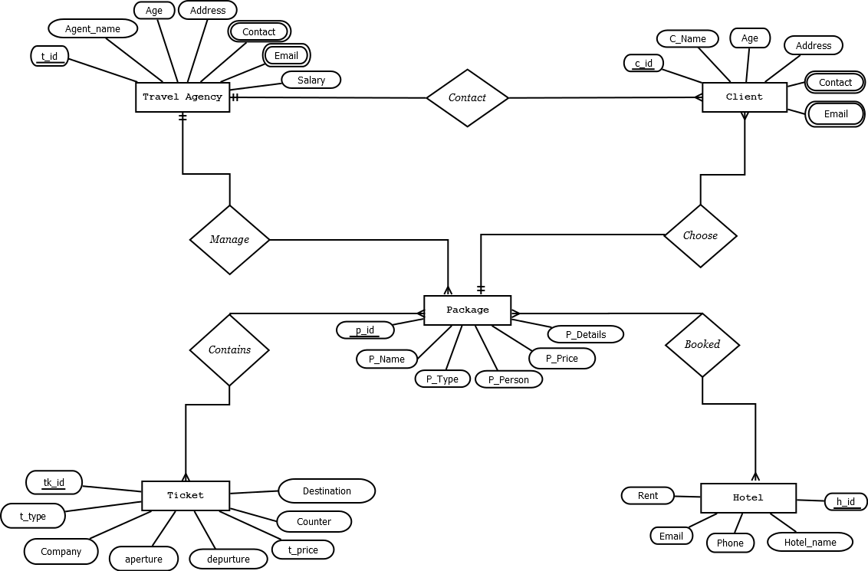

Normalization

Contact: (T_id, agent_name, age, address, contact, email, job, salary, C_id, c_name, age, address, contact, email)

1NF → TRAVEL_AGENCY

CLIENT

2NF → T_id, agent_name, age, address, contact, email, job, salary

C_id, c_name,age, address, contact, email

3NF → No transitive dependency.

Table list for contact:

1. T_id, agent_name, age, address, salary

2. T_id, contact→ composite primary key

3. T_id, email→ composite primary key

4. C_id, c_name, age, address, T_id, P_id

5. C_id, contact→ composite primary key

6. C_id, email→ composite primary key

Manage: (T_id, agent_name, age, address, contact, email, job , salary, P_id, p_name, p_type, p_person, p_price, p_details)

1NF→ Contact is a multivalued attribute

Email is a multivalued attribute

2NF→ T_id, agent_name, age, address, contact, email, job, salary

P_id, p_name, p_type, p_person, p_price, p_details

3NF→ T_id, agent_name, age, address, contact, email

P_id, p_name

P2_id, p_type, p_person, p_price, p_details

Table list from manage:

7. T_id, agent_name, age, address, job, salary

8. T_id, contact→ composite primary key

9. T_id, email→ composite primary key

10. P_id, p_name, P2_id, T-id

11. P2_id, p_type, p_person, p_price, p_details

Choose: (C_id, c_name, age, address, contact, email, P_id, p_name, p_type, p_person, p_price, p_details)

1NF→ Contact is a multivalued attribute.

Email is a multivalued attribute.

2NF→ C_id, c_name, age, address, contact, email

P_id, p_name, p_type, p_person, p_price, p_details

3NF→ C_id, C_name, age, address, contact, email

P_id, p_name

Ps_id, p_type, p_person, p_price, p_details

Table list from choose:

12. C_id, C_name, age, address, P_id

13. C_id, contact→ composite primary key

14. C_id, email→ composite primary key

15. P_id, p_name, P2-id

16. P2_id, p_type, p_person, p_price, p_details

Contains: (P_id, p_name, p_type, p_person, p_price, p_details, TK_id, t_type, company, aperture, departure, t_price,counter,destination)

1NF→ No multivalued attribute

2NF→ P_id, p_name, p_type, p_person, p_price, p_details

TK_id, t_type, company, aperture, departure, t_price, counter, destination

3NF→ P_id, p_name

p2_id, p_type, p_person, p_price, p_details

TK_id, company, aperture, departure, t_type, t_price, counter, destination

Table list from contains:

17. P_id, p_name, p_details, P2_id

18. P2_id, p_type, p_person, p_price, p_details

19. TK_id, company, aperture, departure, t_type, t_price, counter, destination

20. N1_id, P_id, tk_id

Booked: (P_id, p_name, p_person, p_price, p_details, H_id, hotel_name, phone, email,rent)

1NF→ No multivalued attribute.

2NF→ P_id, p_name, p_type, p_person, p_price, p_details

H_id, hotel_name, phone, email, rent

3NF→ P_id, p_name

P2_id, P_type, p_person, p_price, p_details

H_id, hotel_name, phone, email,rent

Table list from booked:

21. P_id, p_name, P2_id

22. P2_id, p_type, p_person, p_price, p_details

23. H_id, hotel_name, phone, email, rent

24. N2_id, P_id, H_id

|  |  |  |
| --- | --- | --- |
| Table number | Table name | Column |
| 01 | TRAVEL_ANGENCY | T-id, agent_name, age, address, job, salary |
| 02 | TA_CONTACT | T_id, contact→ composite primary key |
| 03 | TA_EMAIL | T_id, email→ composite primary key |
| 04 | CLIENT | C_id, c_name, age, address, T_id, P_id |
| 05 | C_CONTACT | C_id, contact→ composite primary key |
| 06 | C_EMAIL | C_id, email→ composite primary key |
| 07 | PACKAGE | P_id, p_name, P2_id, T_id |
| 08 | PACKAGE _2 | P2_id, P_type, p_person, p_price, p_details |
| 09 | TICKET | TK_id,company,aperture,departure,t_type,t_price,counter,destination |
| 10 | NEW_TABLE_1 | N1_id, P_id, TK_id |
| 11 | HOTEL | H_id, hotel_name, phone, email, rent |
| 12 | NEW_TABLE_2 | N2_id, P_id, H_id |

Final table list:

DDL & DML

TRAVEL_AGENCY:

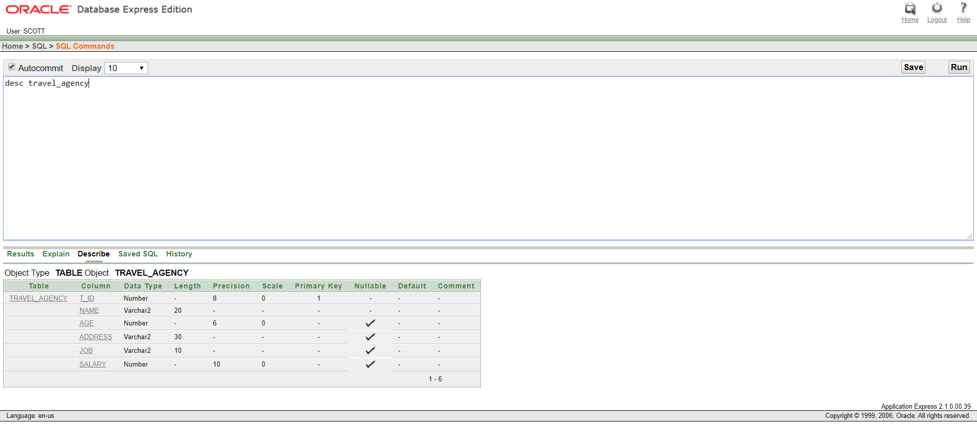

Description of TRAVEL_AGENCY

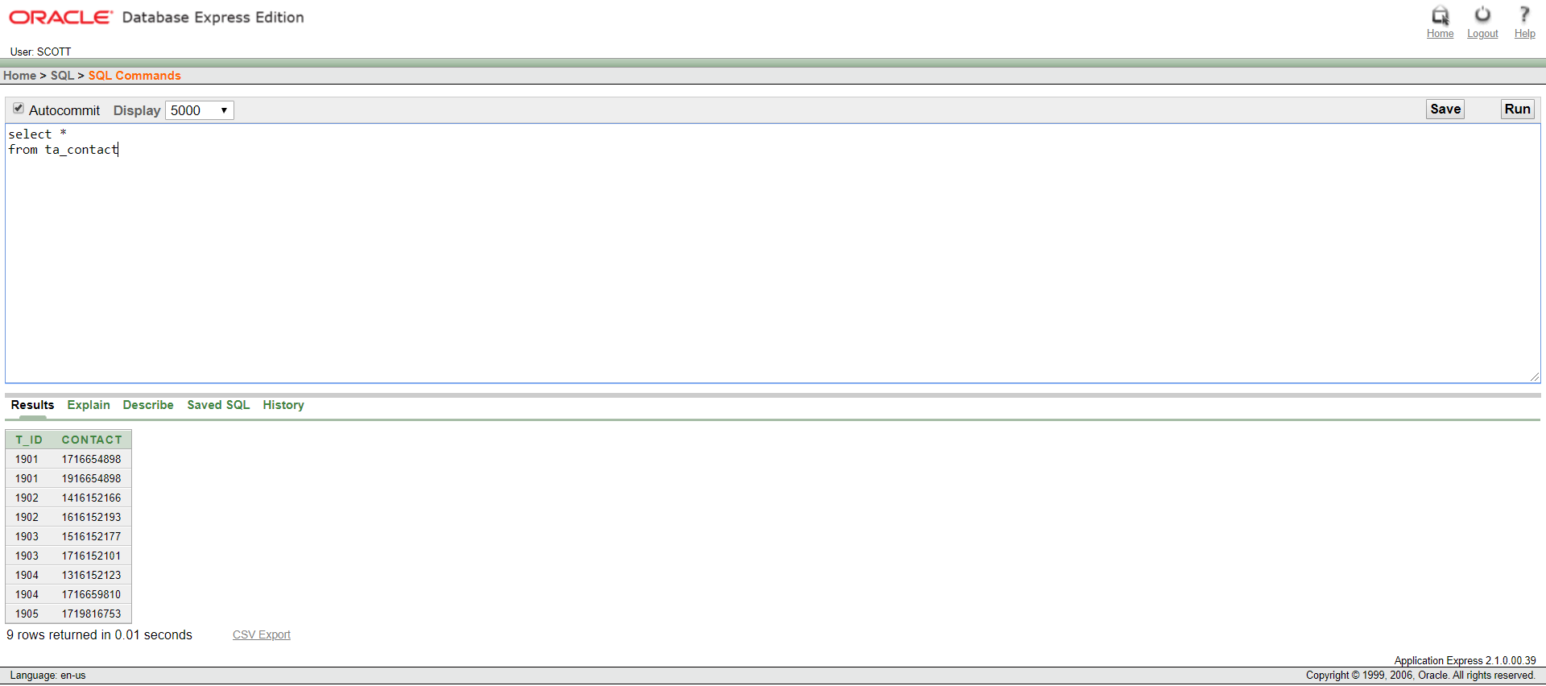

Description of TA_CONTACT

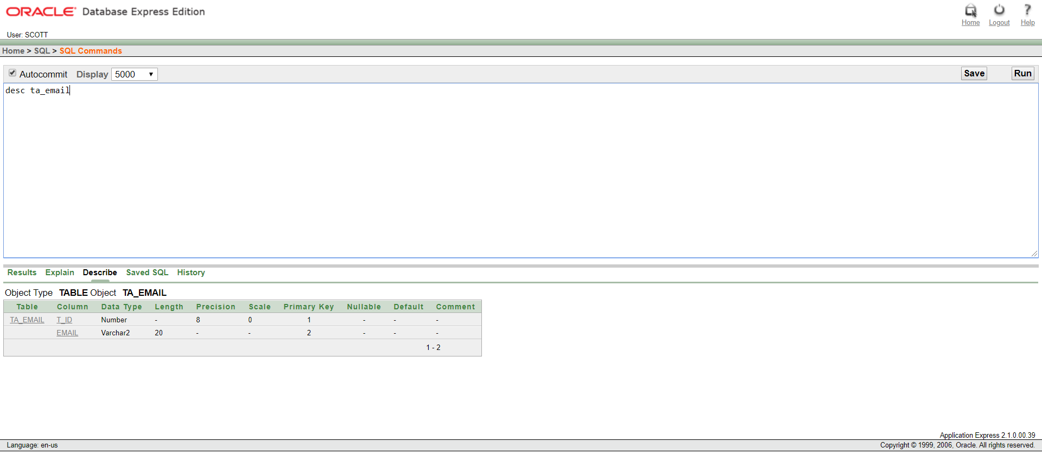

Description of TA_EMAIL

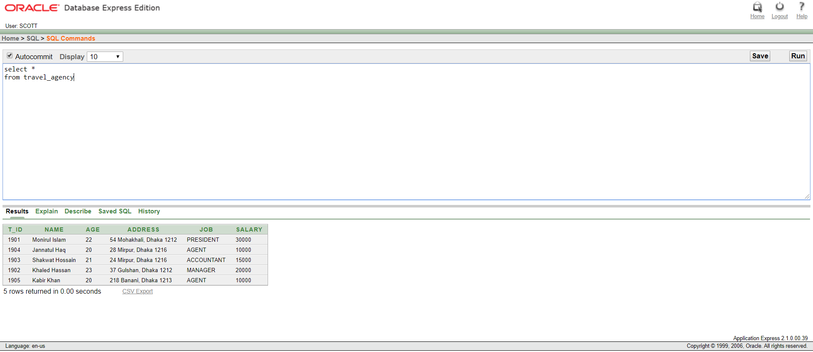

Table: TRAVEL_AGENCY



Table: TA_CONTACT

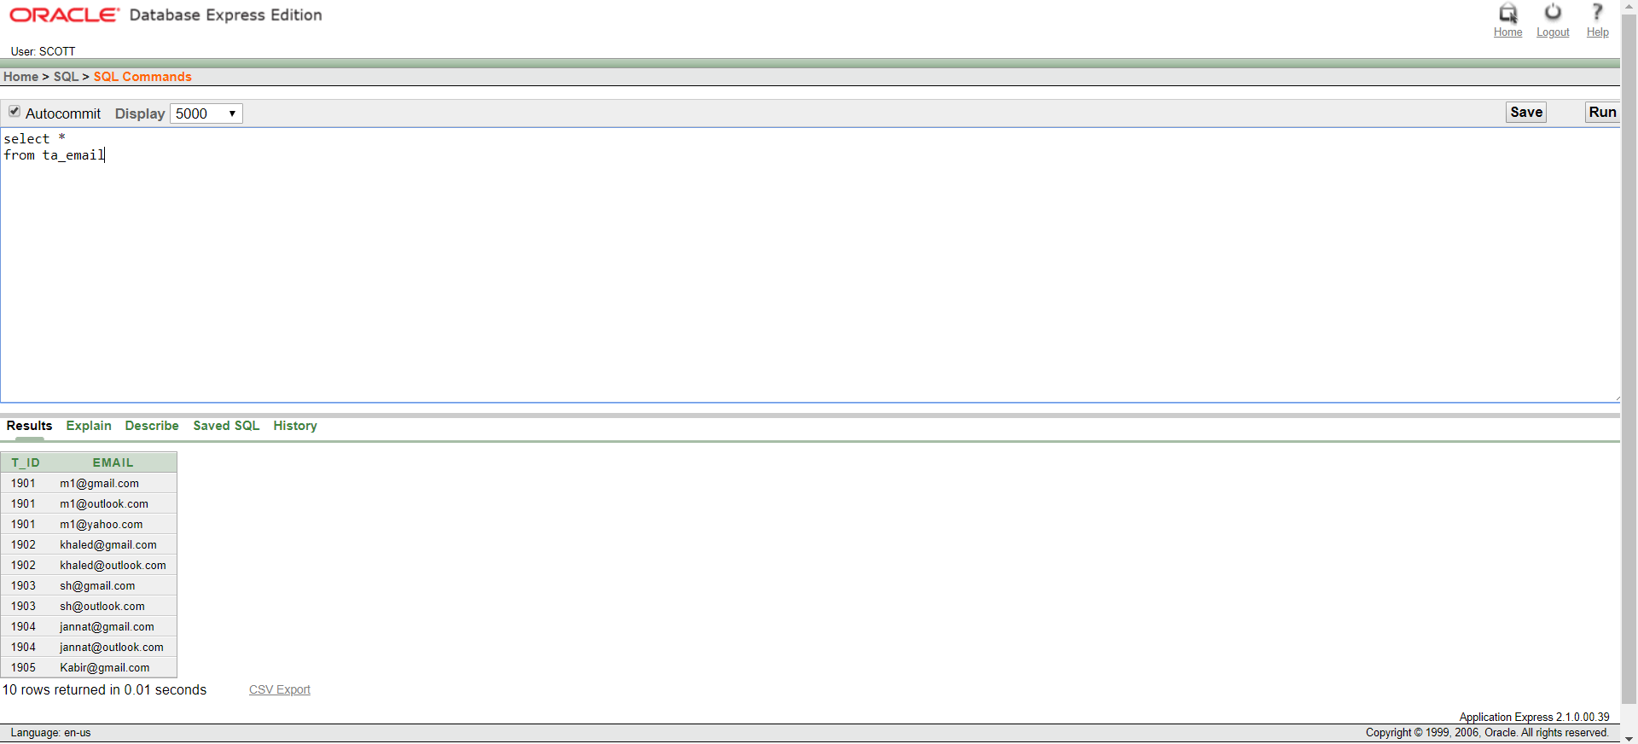

Table: TA_EMAIL

CLIENT:

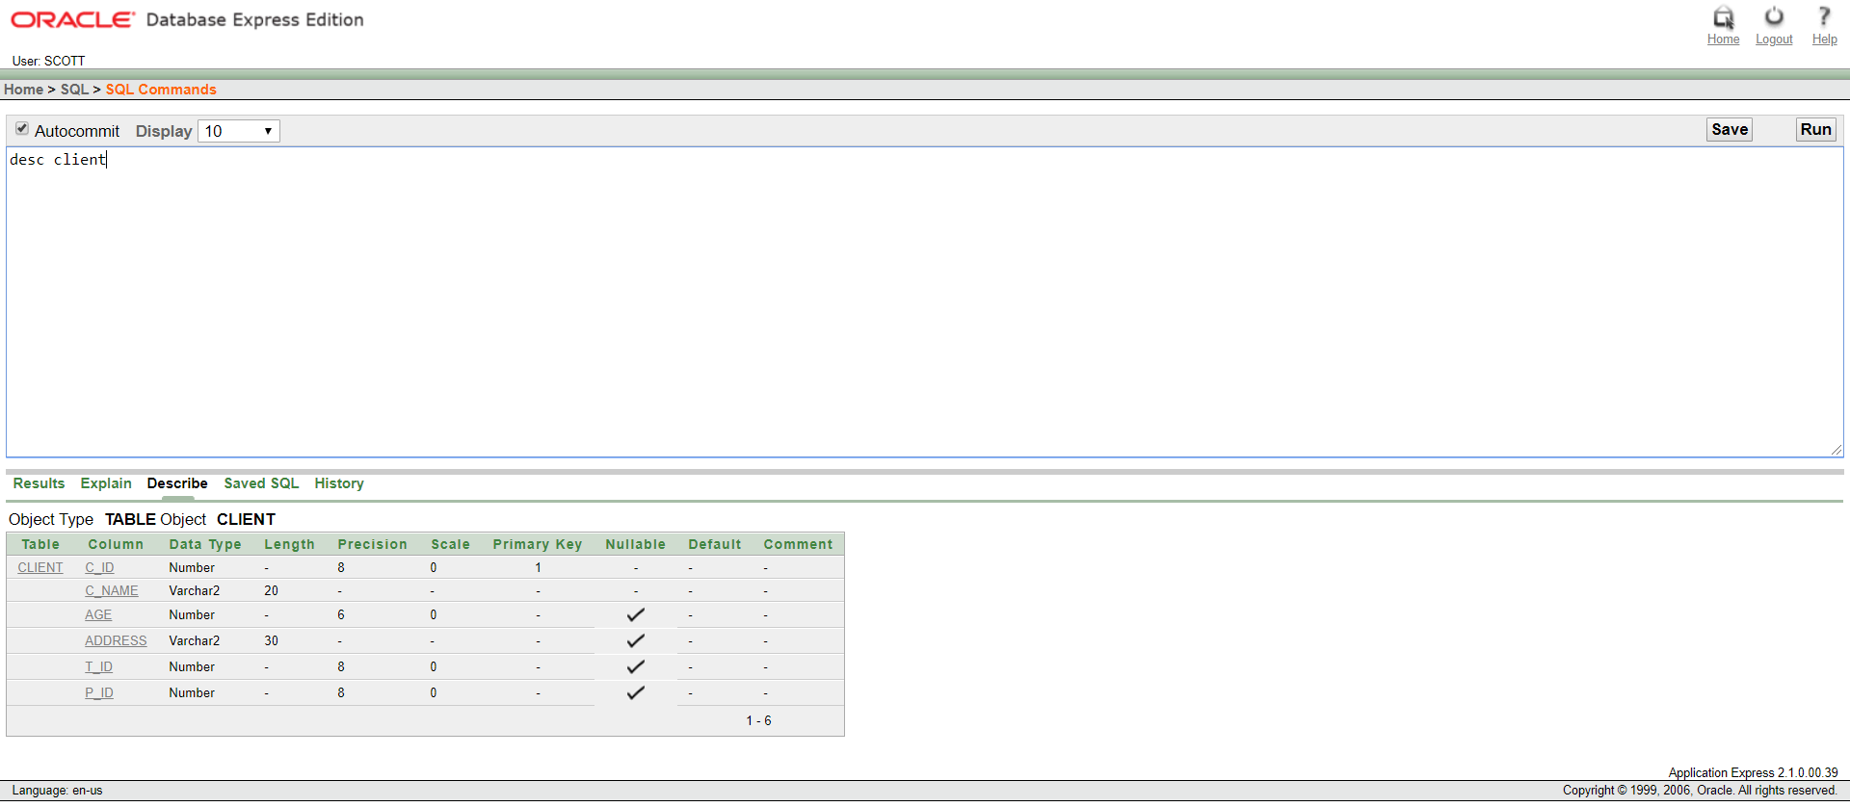

Description of CLIENT

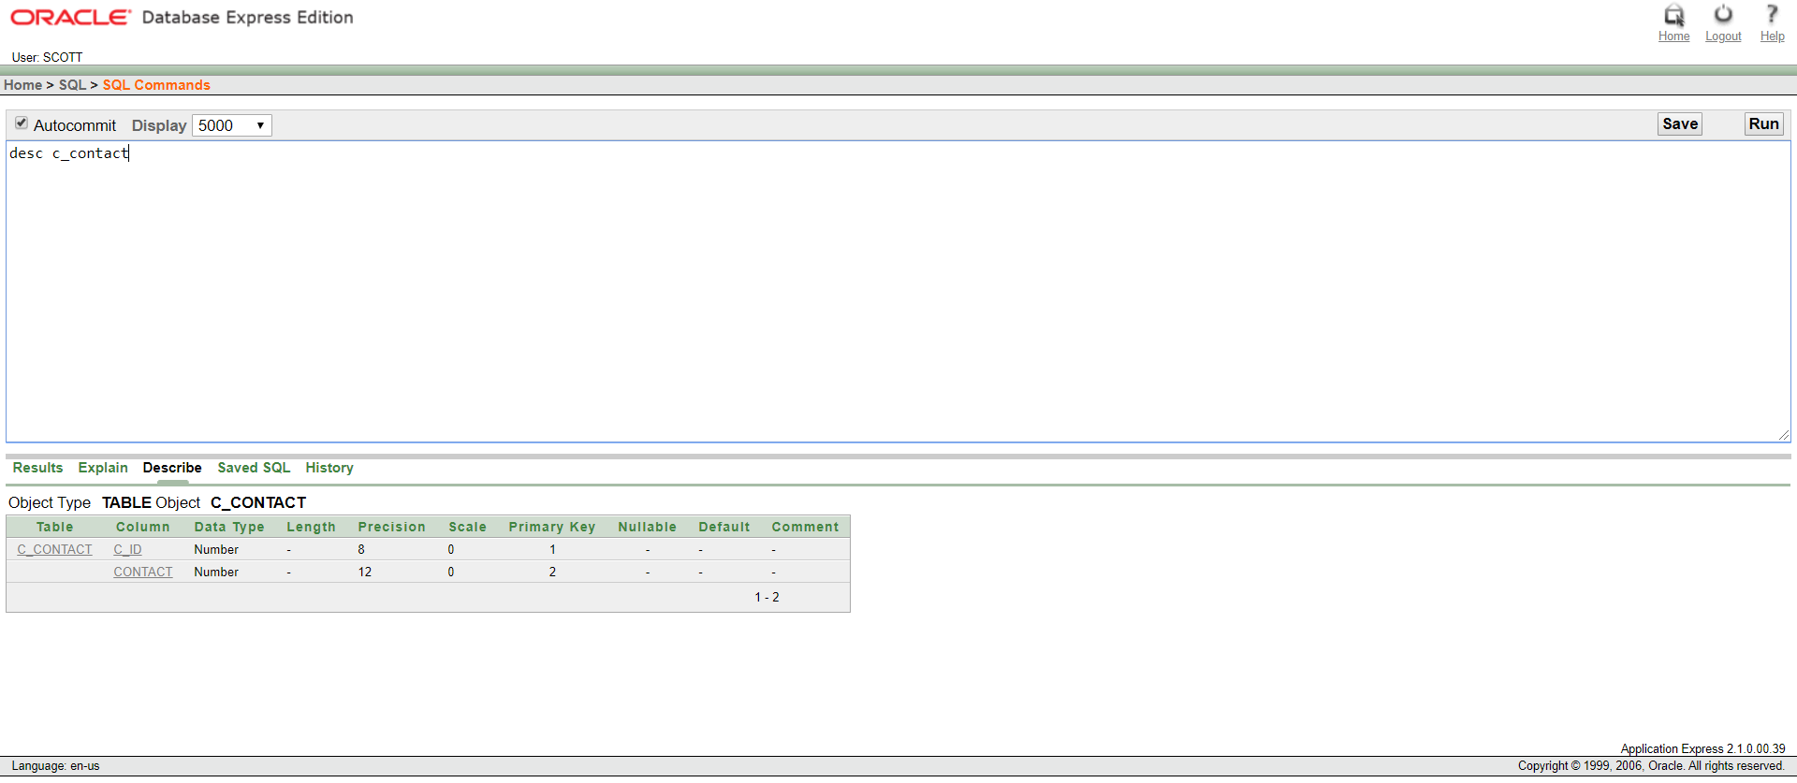

Description of C_CONTACT

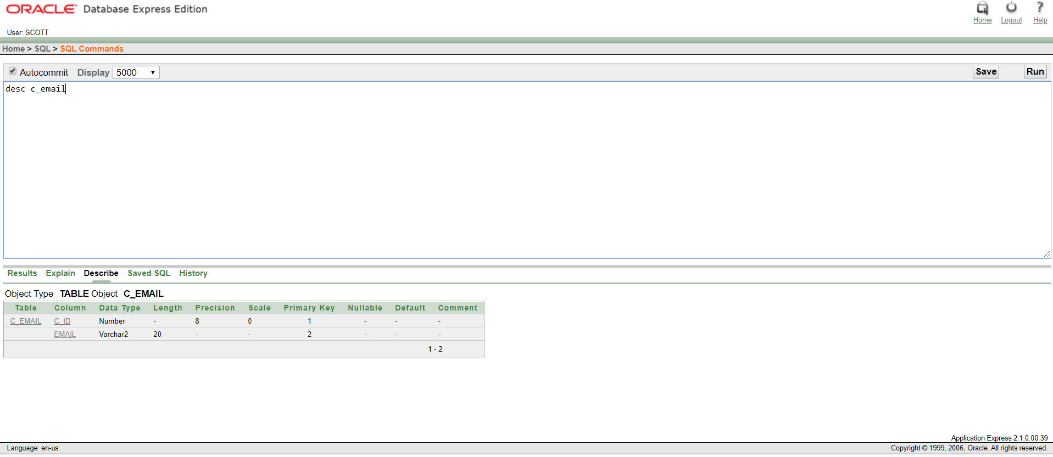

Description of C_EMAIL

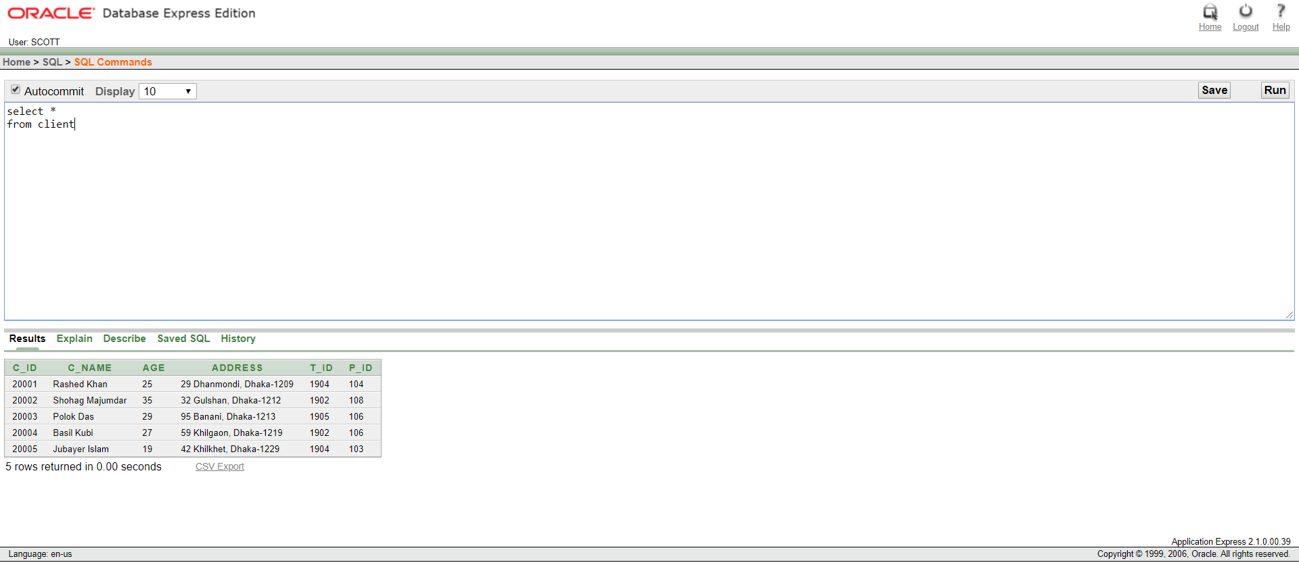

Table: CLIENT

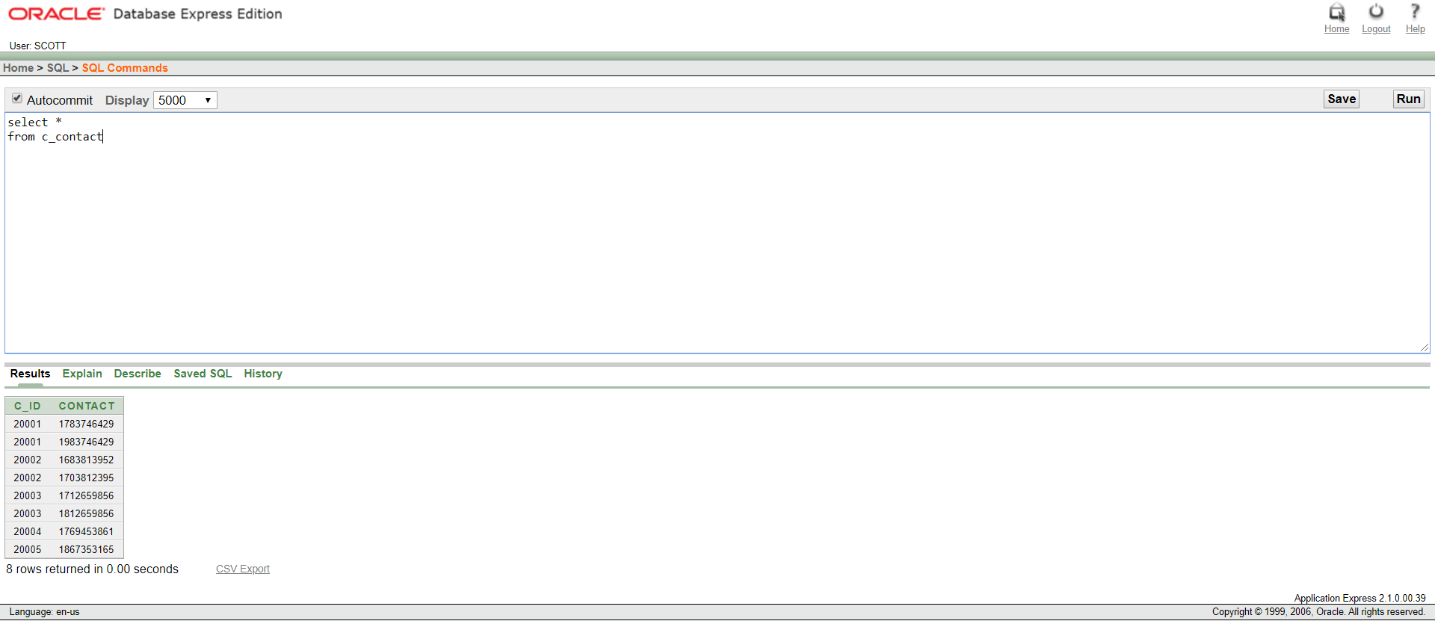

Table: C_CONTACT

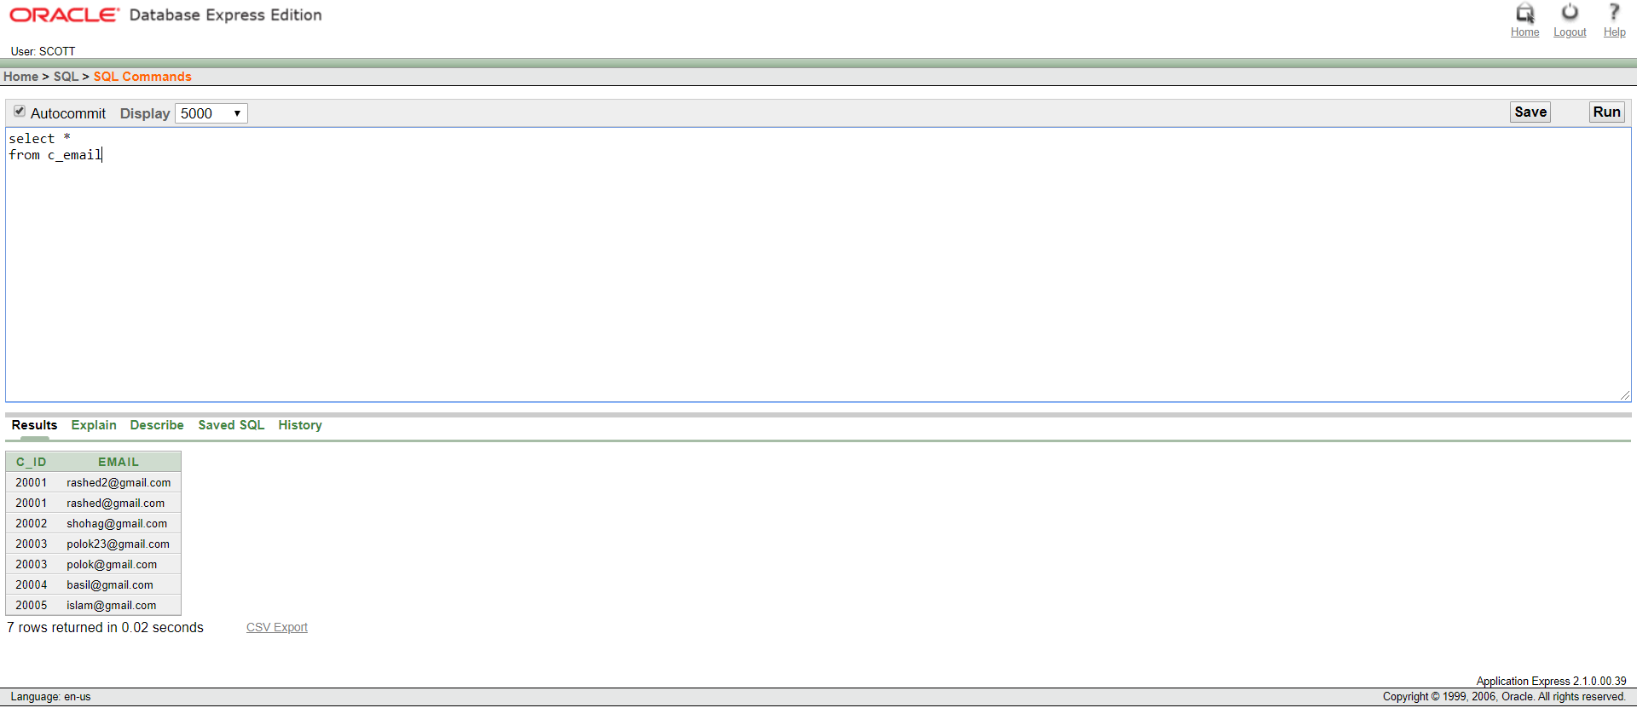

Table: C_EMAIL

PACKAGE:

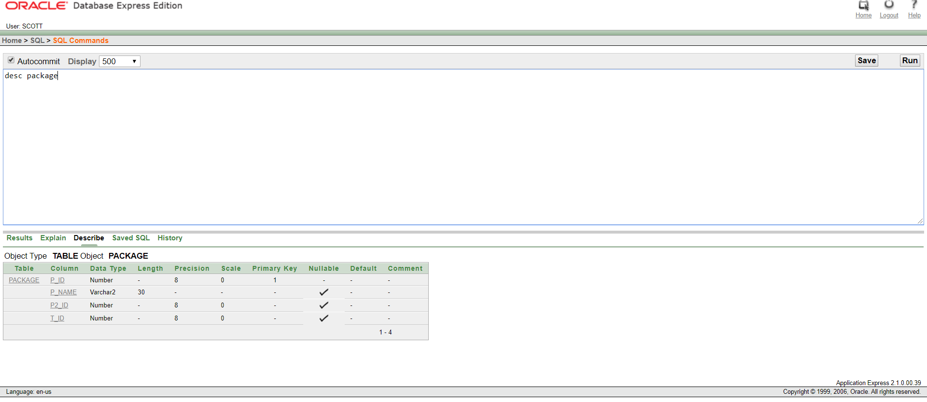

Description of PACKAGE

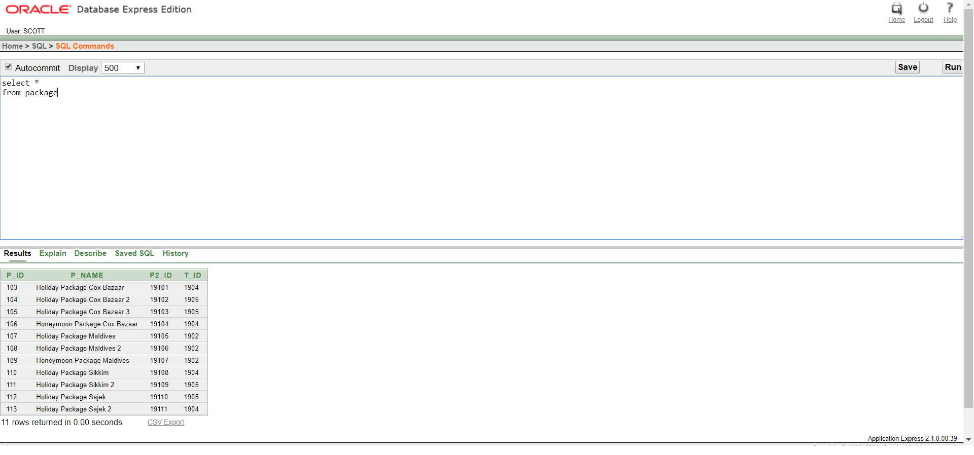

Table: PACKAGE

PACKAGE_2:

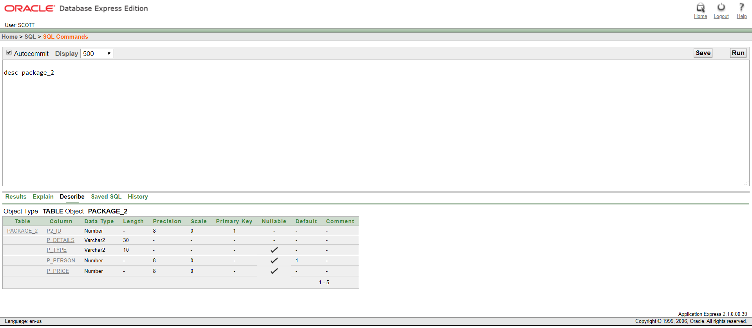

Description of PACKAGE_2

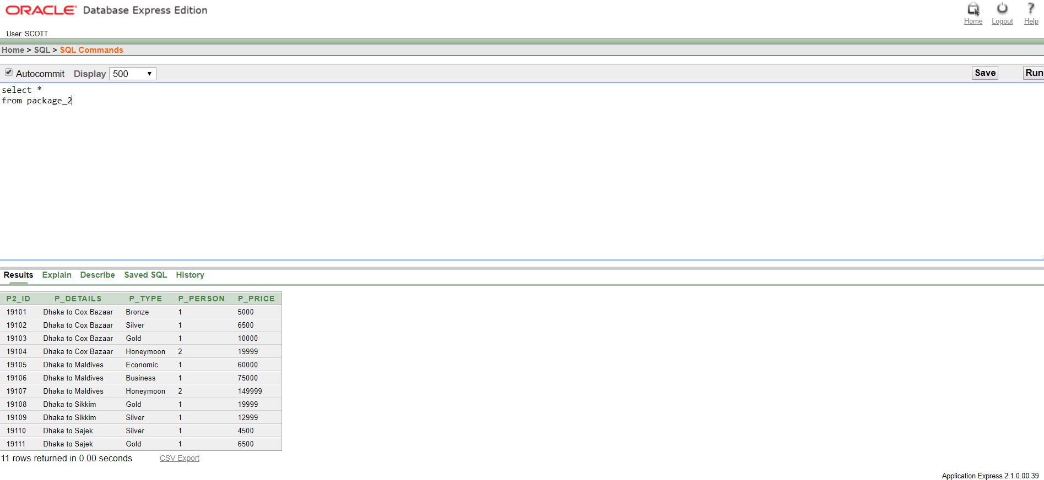

Table: PACKAGE_2

TICKET:

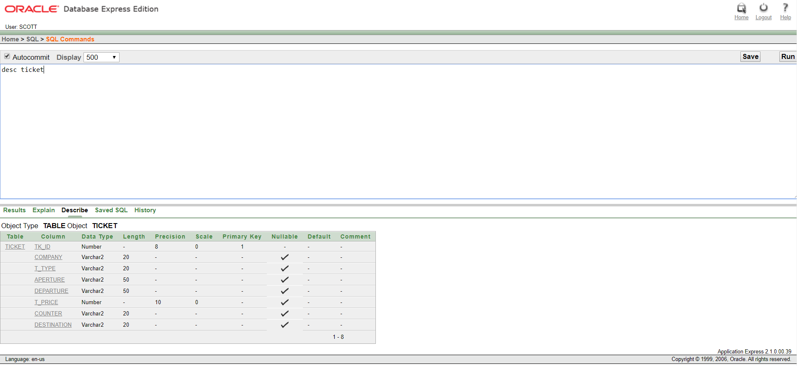

Description of TICKET

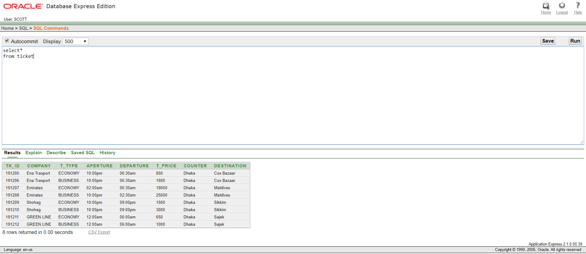

Table: TICKET

NEW_TABLE_1:

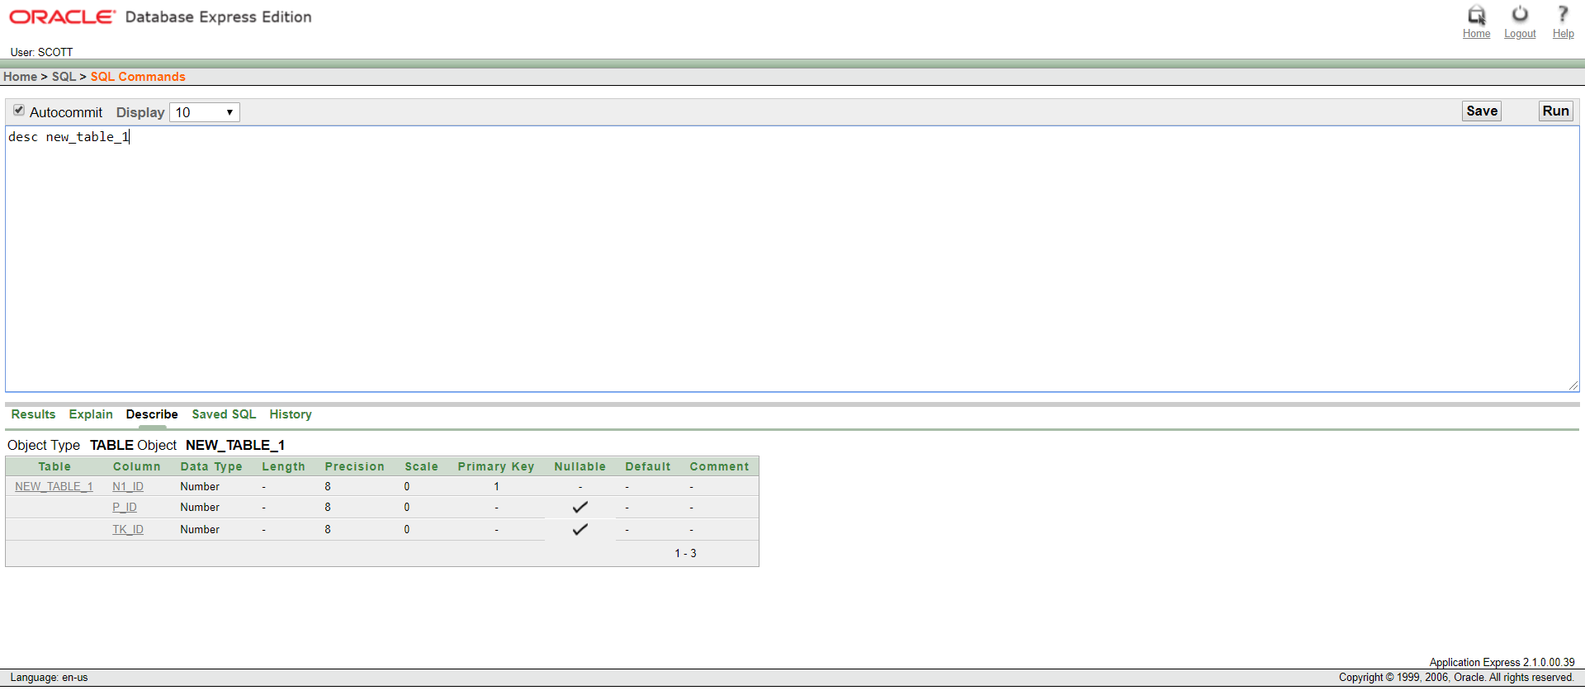

Description of NEW_TABLE_1

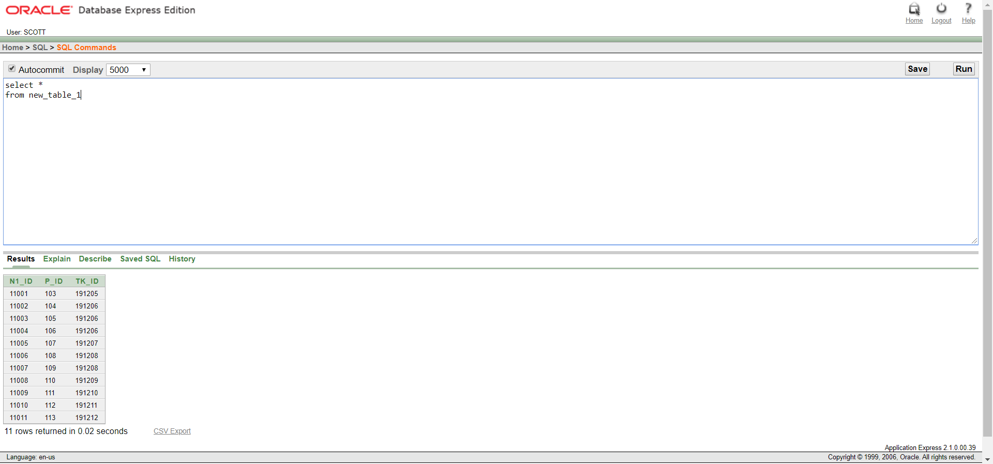

Table: NEW_TABLE_1

HOTEL:

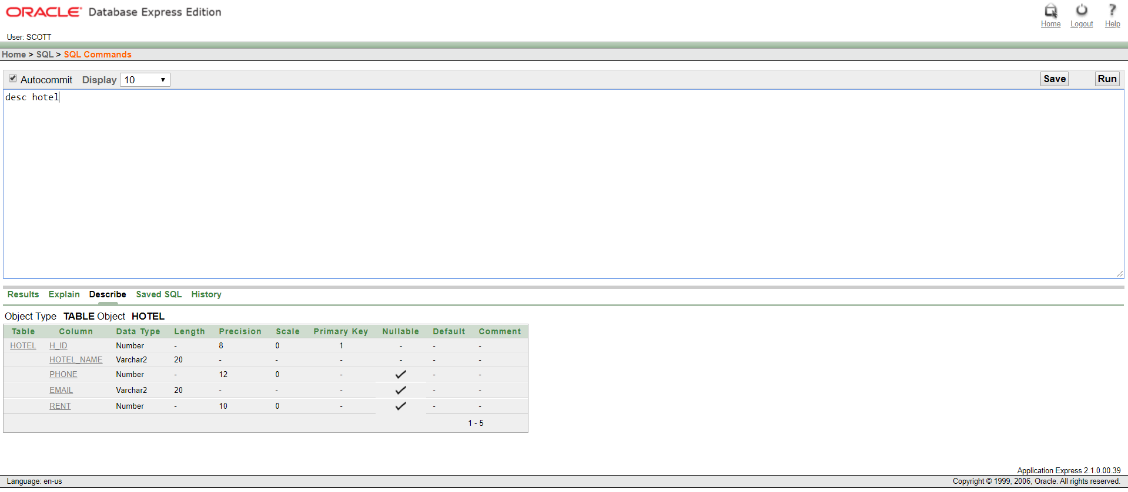

Description of HOTEL

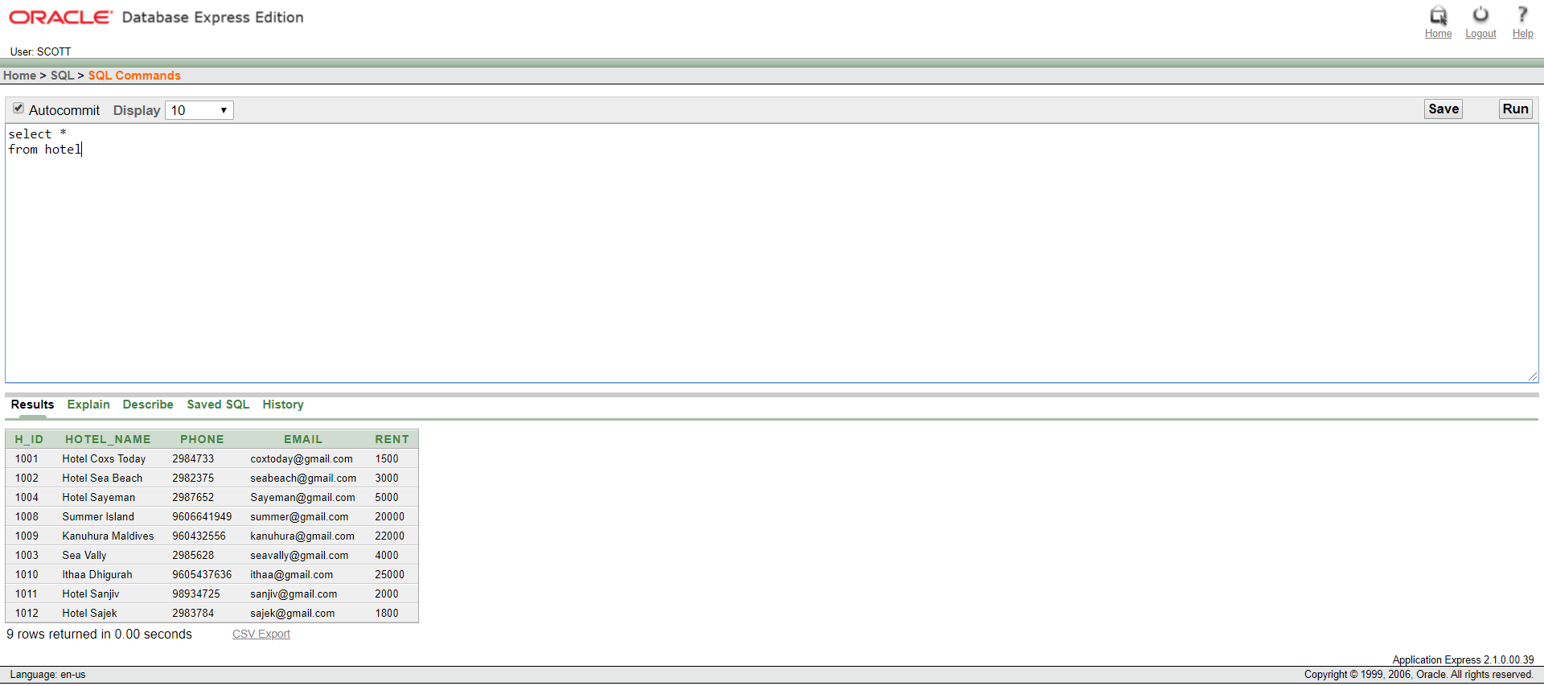

Table: HOTEL

NEW_TABLE_2:

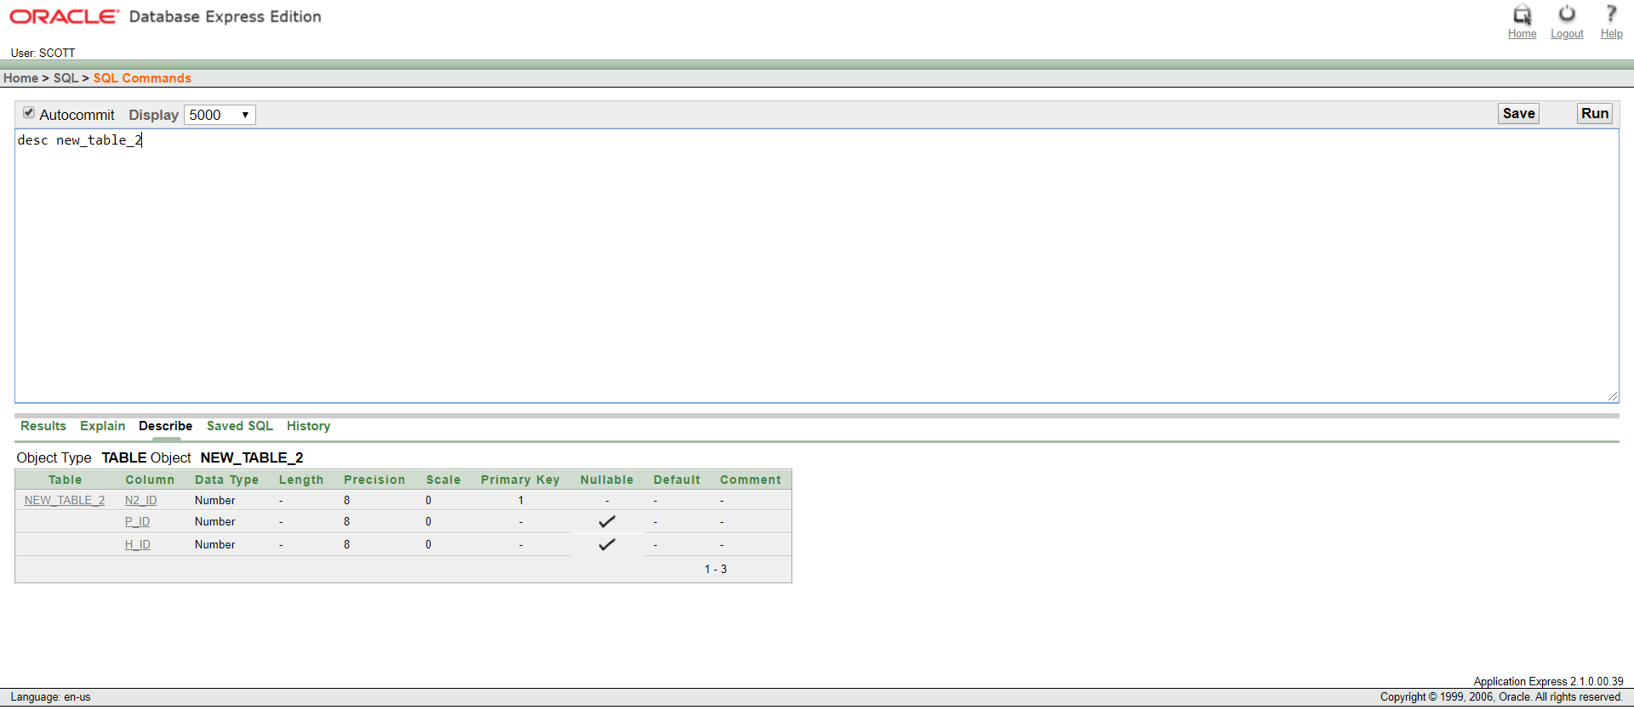

Description of NEW_TABLE_2

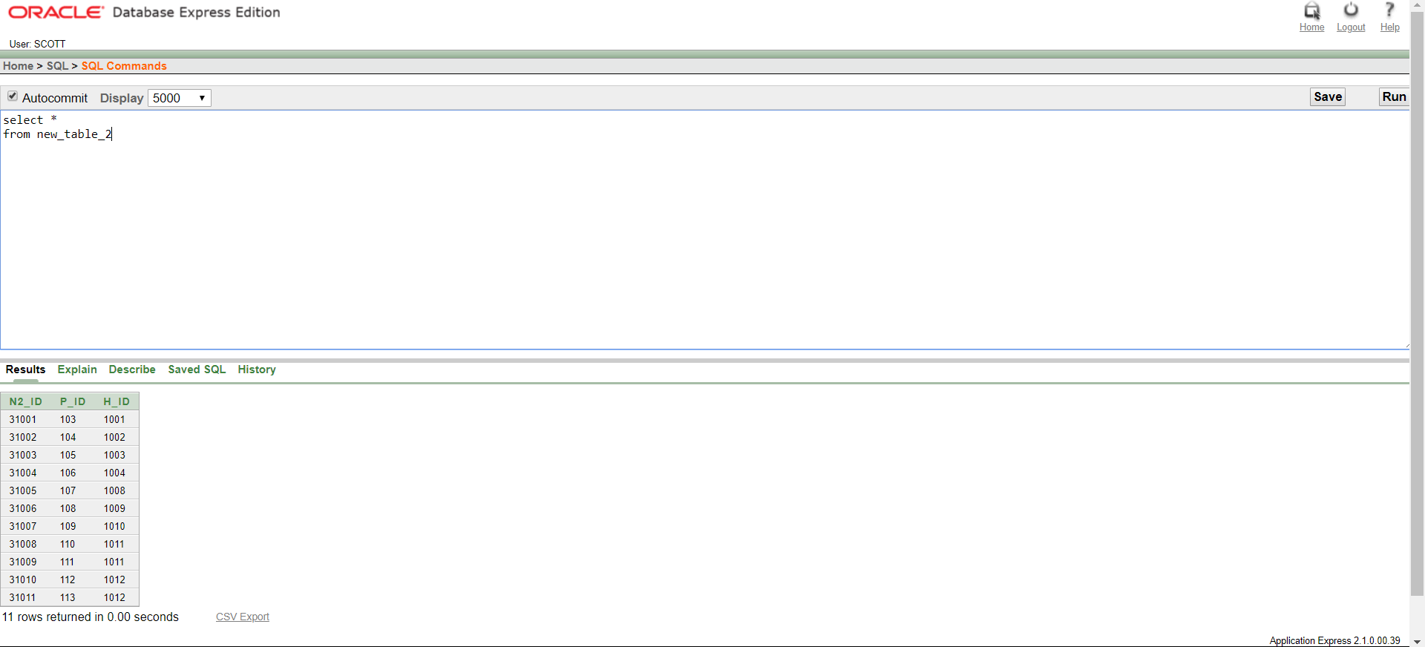

Table: NEW_TABLE 2

Constraints

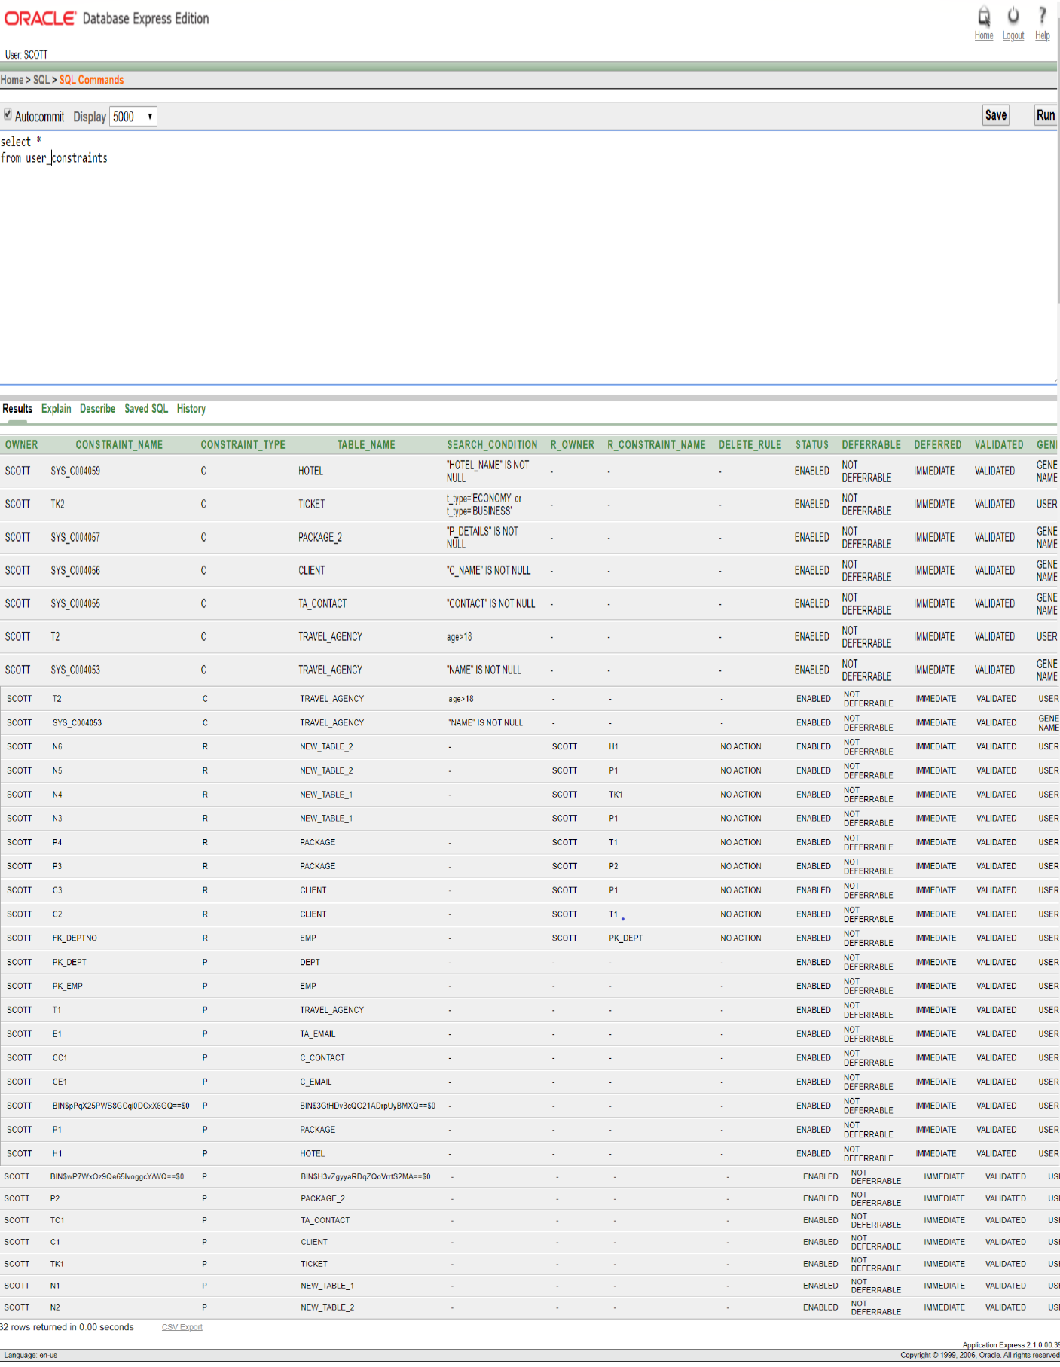

SEQUENECE

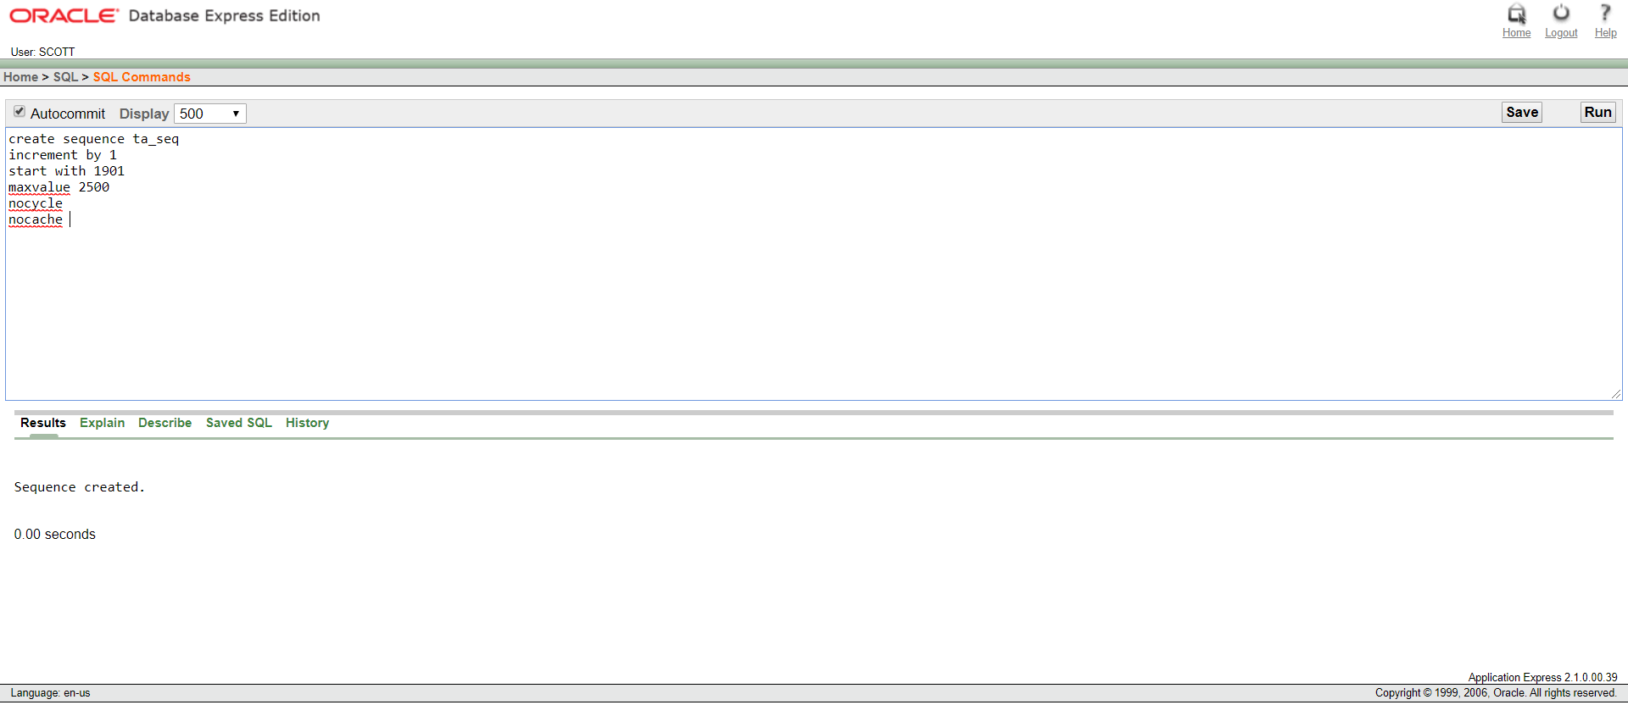

Sequence for TRAVEL_AGENCY

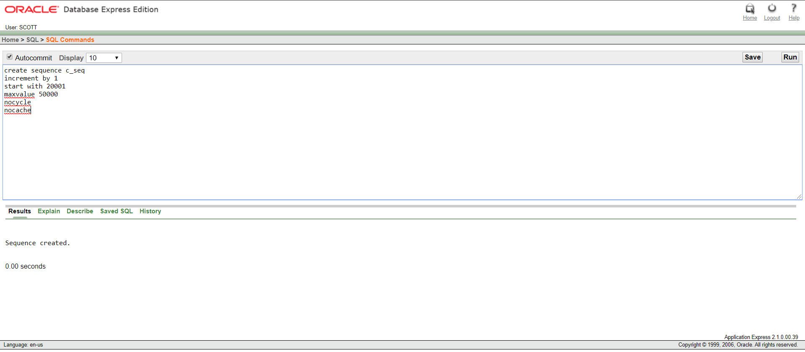

Sequence for CLIENT

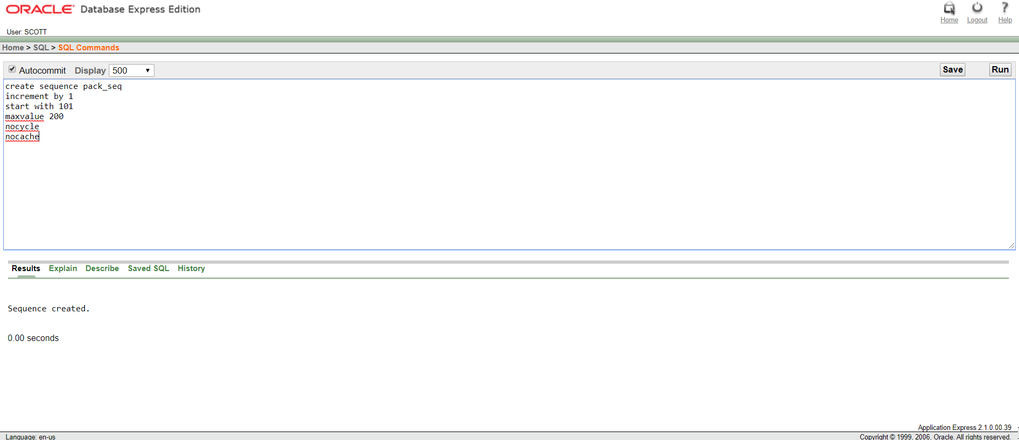

Sequence for PACKAGE

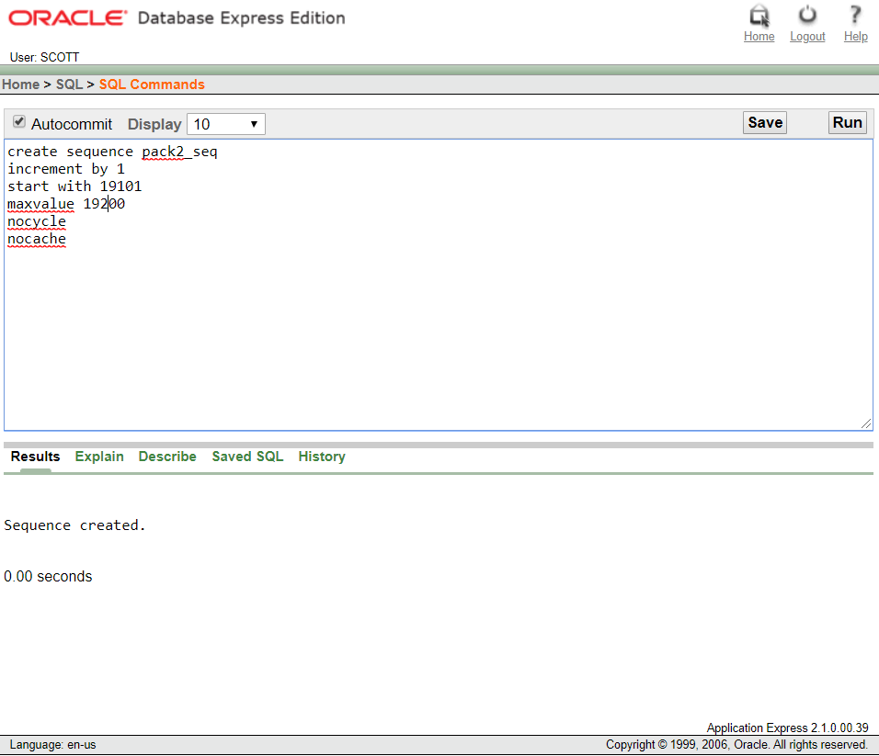

Sequence for PACKAGE_2

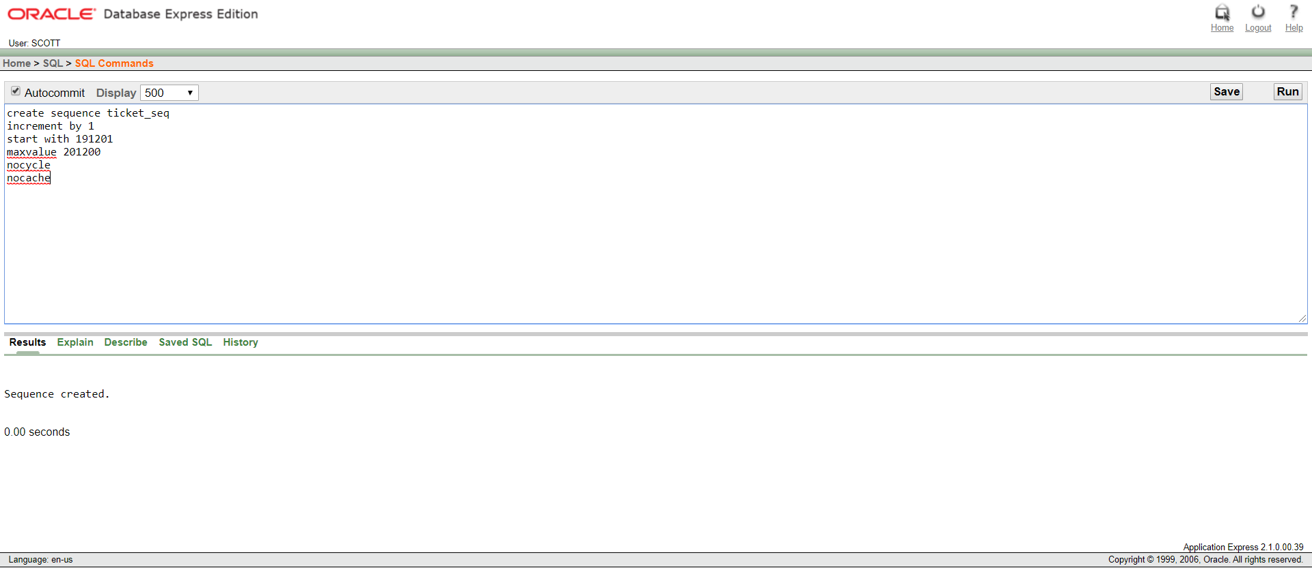

Sequence for TICKET

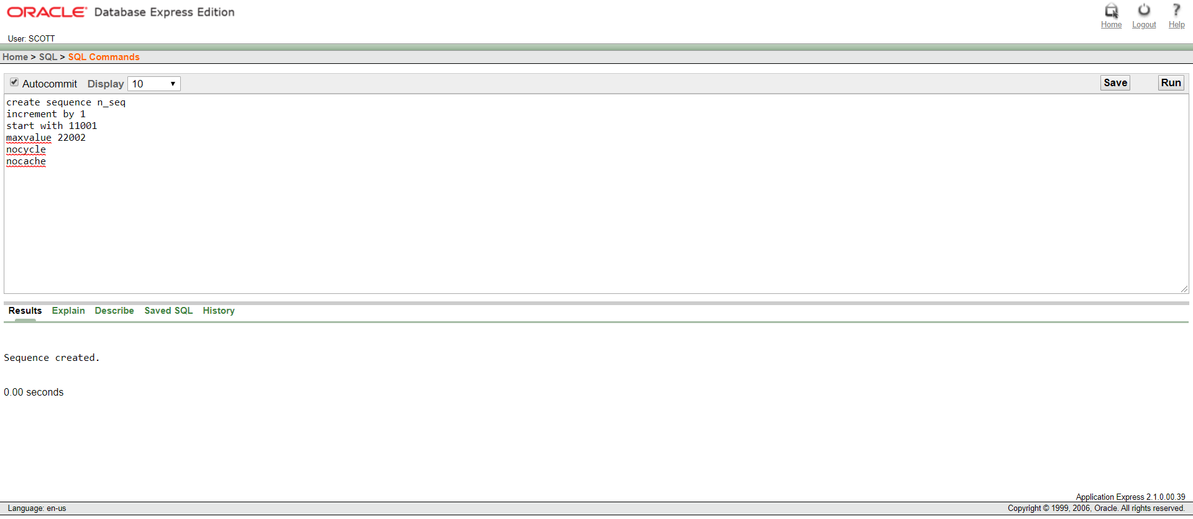

Sequence for NEW_TABLE_1

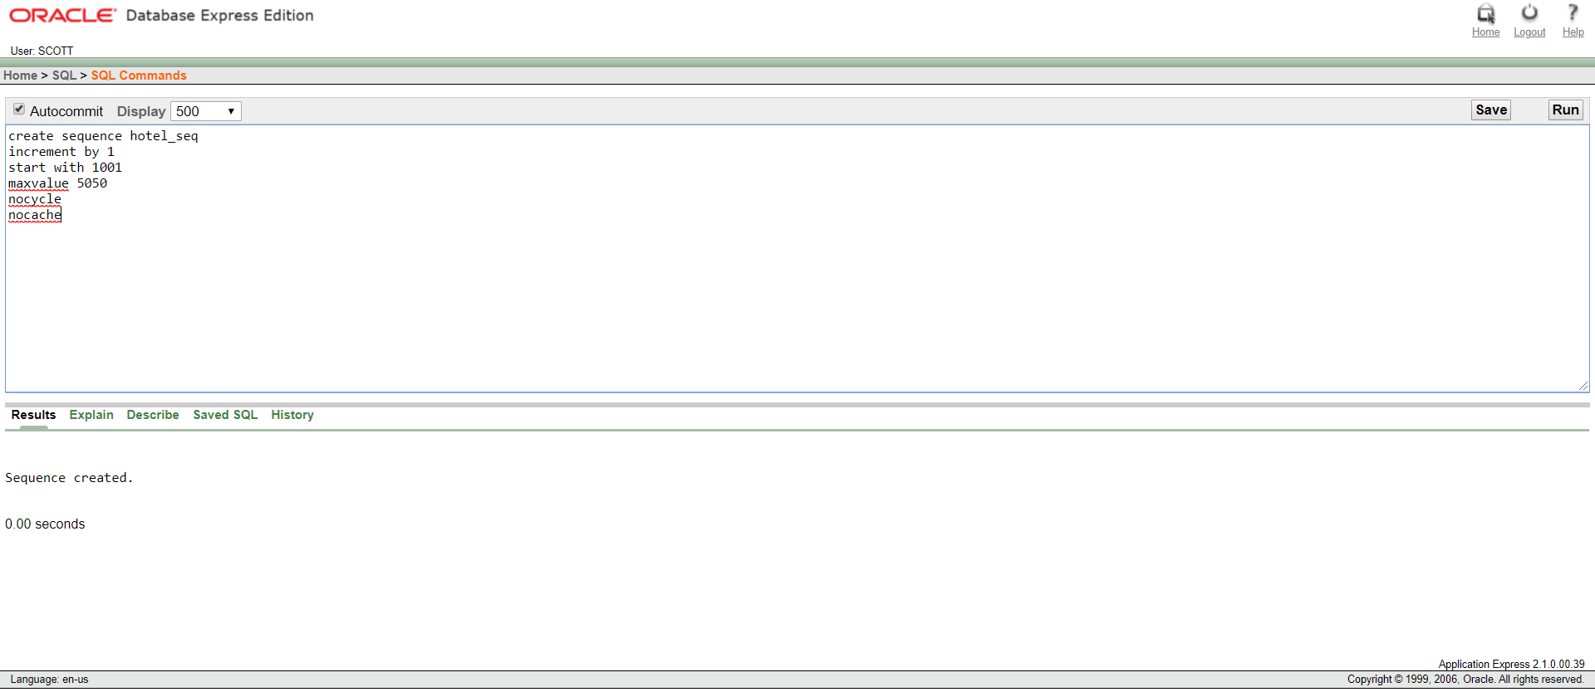

Sequence for HOTEL

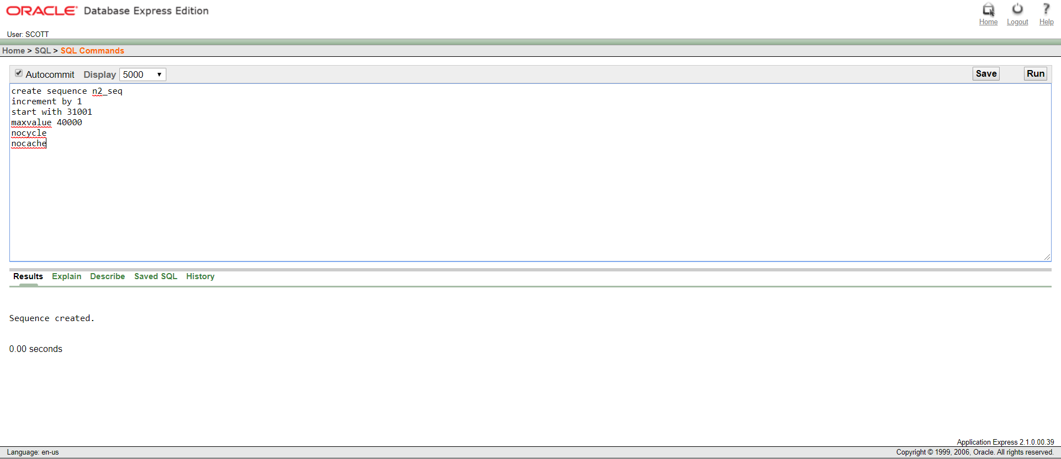

Sequence for NEW_TABLE_2